**B2B Travel Company**

Final Report

**Objective:**

The objective of this project was to develop a B2B travel company website designed to streamline travel management for travel agents and corporate clients. The key goals were:

**1. Centralized Travel Management:** Integrate multiple travel services (flights, trains, buses, hotels, cabs) into one platform for easy booking and management.

**2. User-Friendly Interface:** Create an intuitive, responsive design for seamless navigation across devices.

**3. Real-Time Service Search:** Enable efficient search and booking with real-time data from external APIs.

**4. Secure User Management:** Implement secure login, signup, and personalized dashboards using Firebase.

**5. Payment Integration:** Integrate a straightforward payment gateway for service bookings.

**6. Scalability and Flexibility:** Ensure the platform can scale and adapt to future needs and additional services.

**7. Comprehensive Reporting:** Provide detailed reports and insights for optimizing travel plans.

**Efforts:**

**Week 1:**

- **Header & Hero Section:** Created logo, navigation menu, and search bar. Designed a hero section with a background image, headline, subheadline, quick search options, and call-to-action buttons. Added a chatbot for 24/7 support.

- **Services Overview:** Developed service cards for flights, trains, buses, cabs, and hotels with descriptions.

**Week 2:**

- **Key Features:** Added sections for "Why Choose Us" with feature blocks, "Industries We Serve" with a carousel, and "Client Testimonials." Included a call-to-action section and footer with quick links, social media icons, and a newsletter sign-up form.

**Week 3:**

- **Login & Signup Pages:** Designed login and signup forms with background images, form fields, and prompts. Implemented "Forgot Password" and "Create an Account" options. Added help section and contact form.

**Week 4:**

- **Services Pages:** Created separate pages for flights, trains, buses, cabs, and hotels, each displaying detailed information and booking options with background images.

**Week 5:**

- **Functionality Enhancements:** Implemented buttons for "Explore Services" and "Get Started" on the homepage. Developed working signup and login pages, with data saved in Firebase and navigation to the dashboard.

**Week 6:**

- **API and Data Mockups:** Created basic examples to simulate real-time data for flights, trains, buses, cabs, and hotels. Developed backend infrastructure for data integration, with placeholders for payment functionality.

**Week 7:**

- **Final Touches and Deployment Prep:** Completed input fields and result displays for each service. Added placeholder payment buttons. Prepared the site for deployment via Firebase.

**Output:**

I’m attaching the photos and all for each weeks with the headings:

**Week 1:**

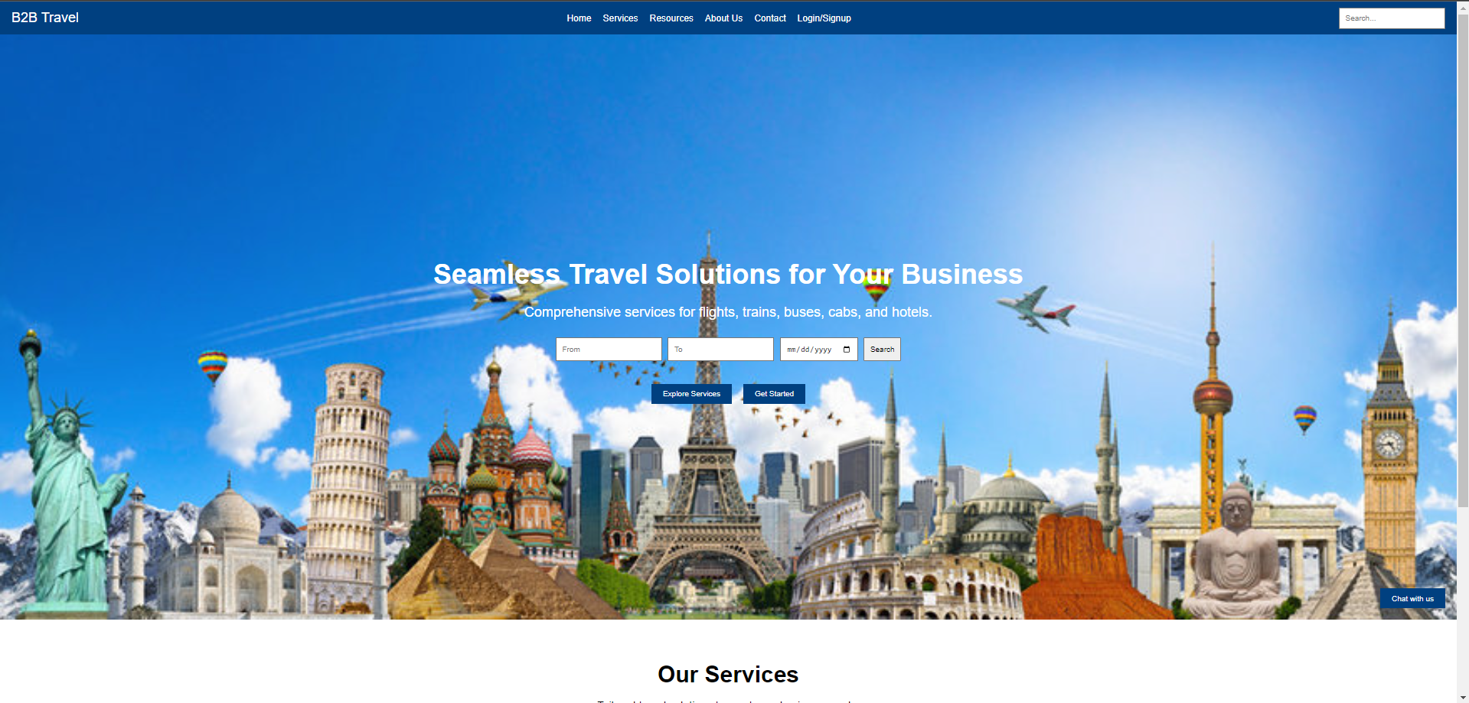

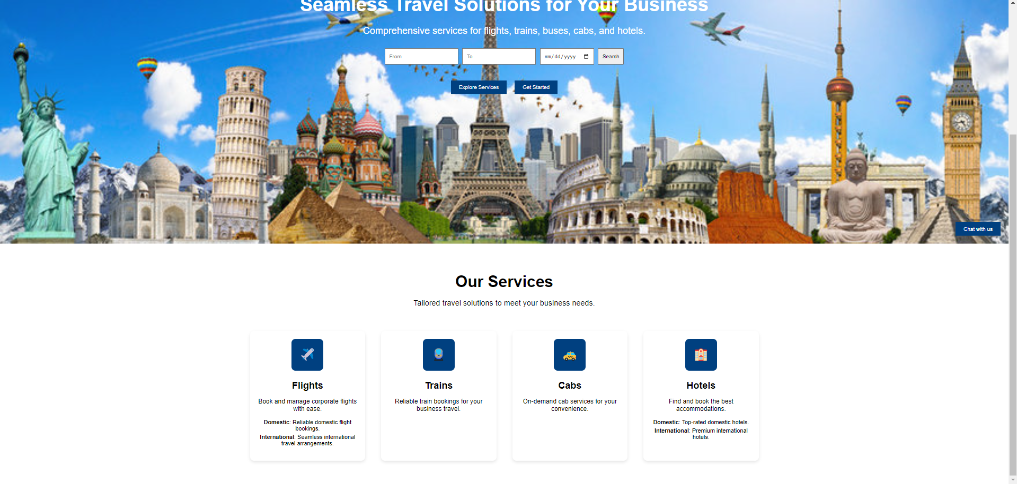

**Week 2:**

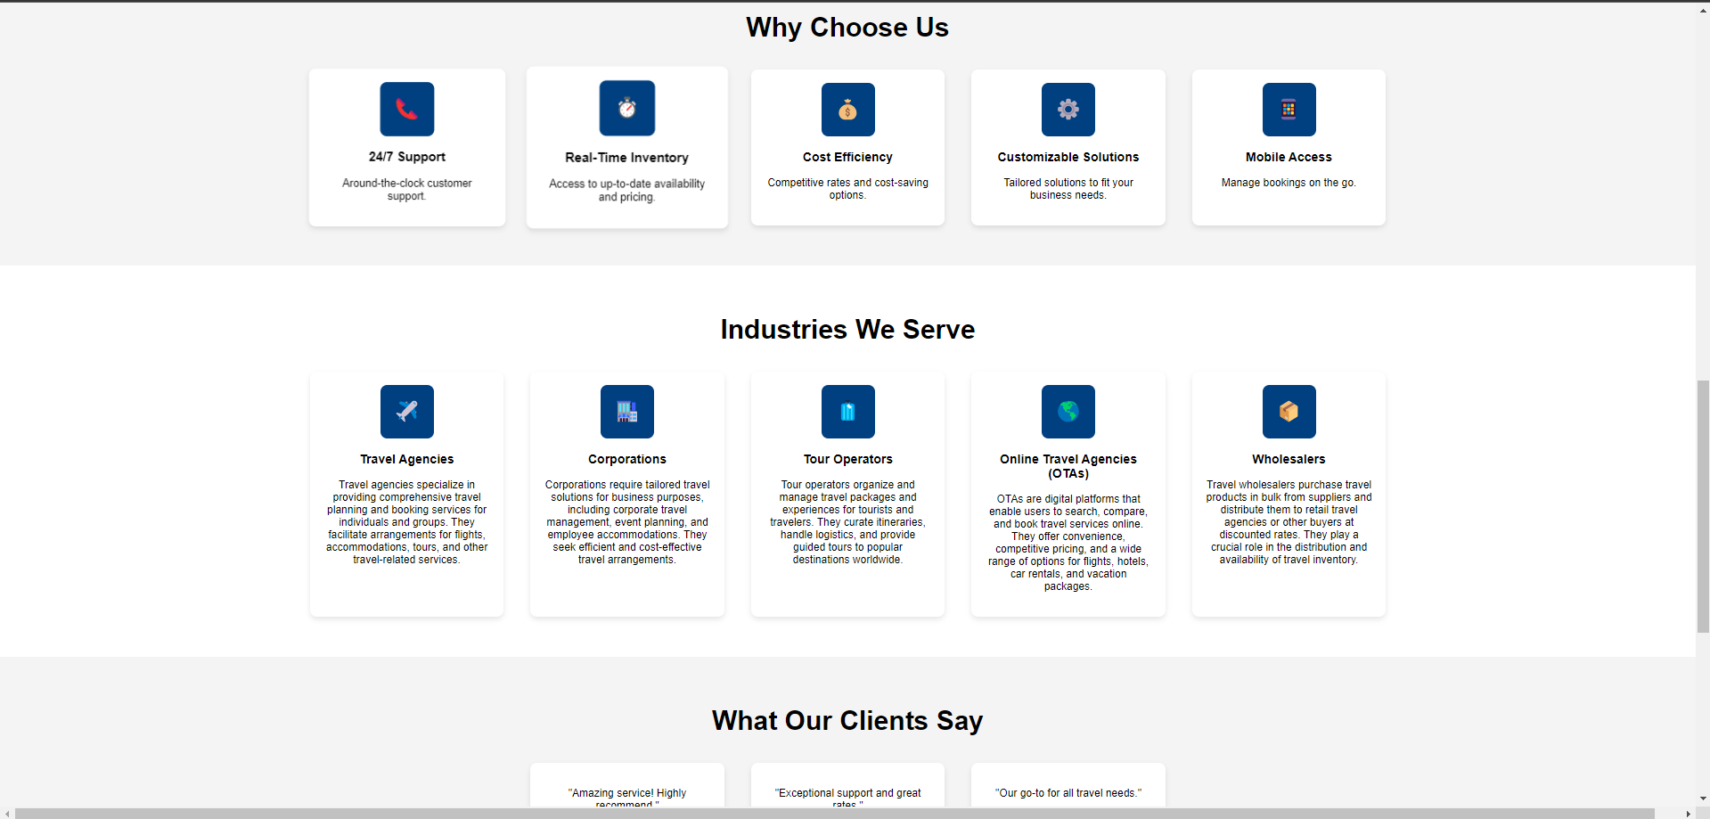

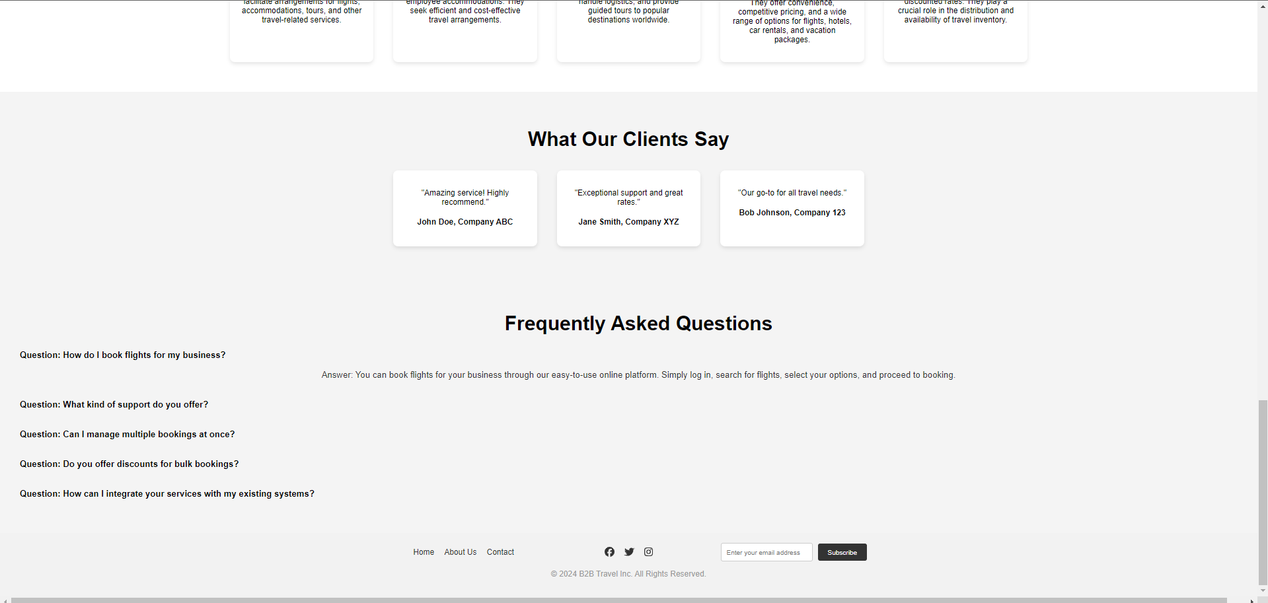

**Week 3:**

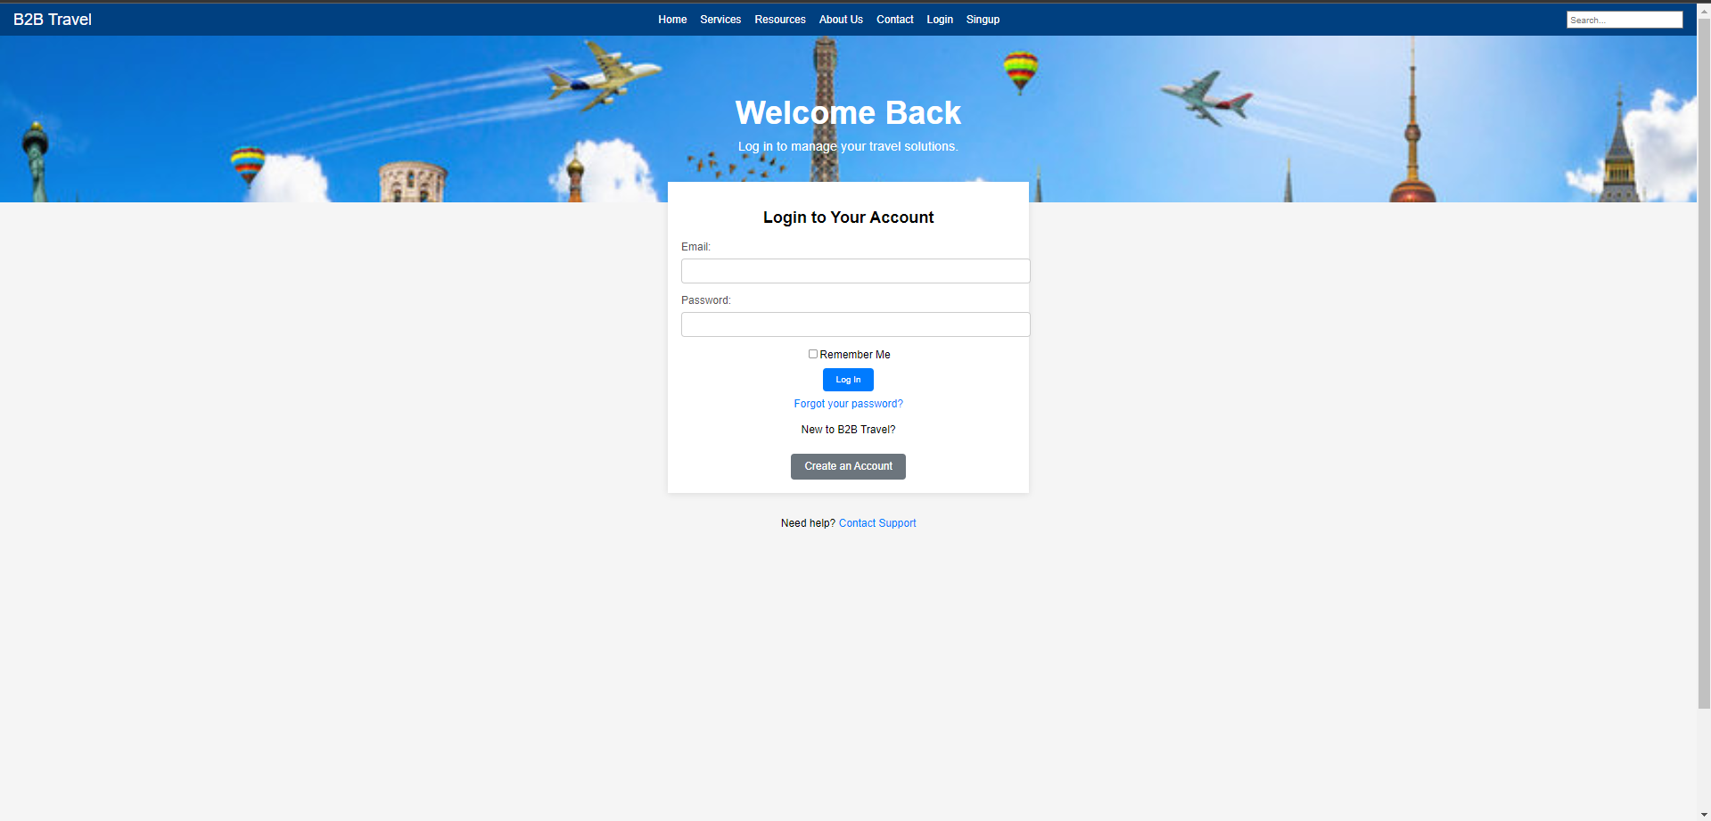

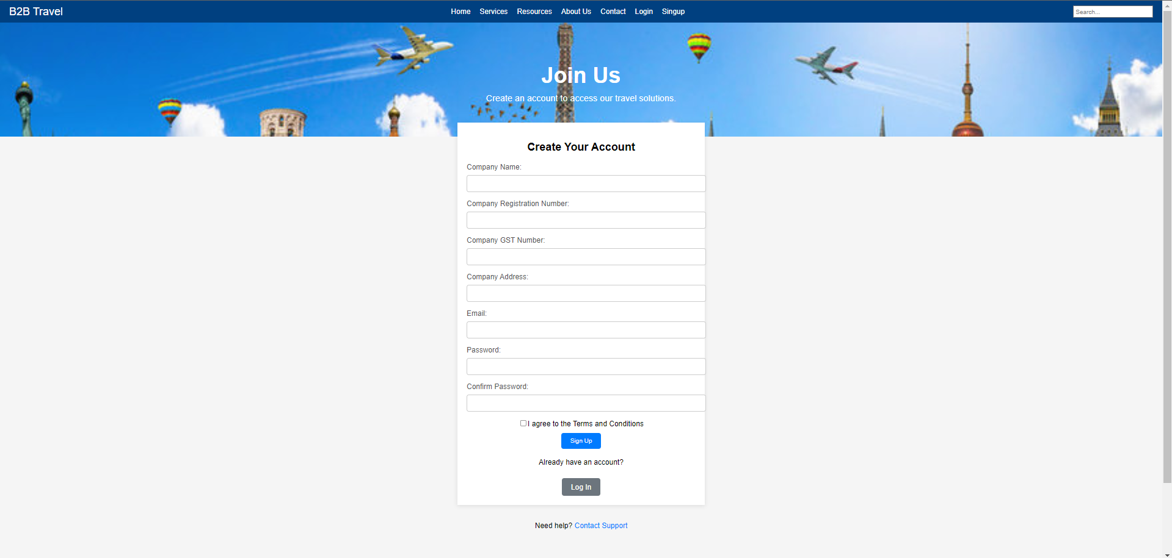

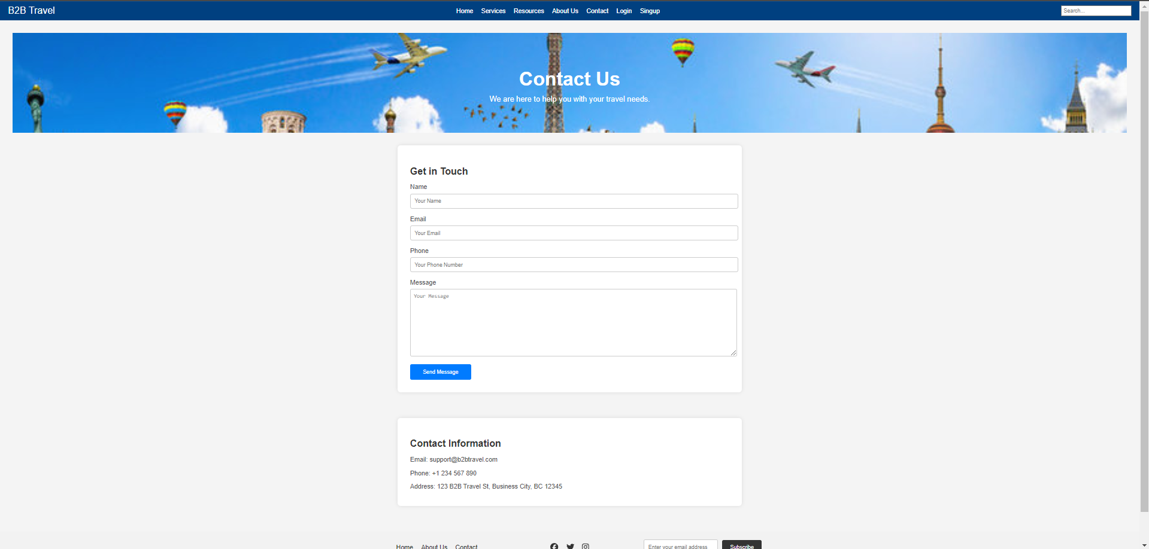

**Week 4:**

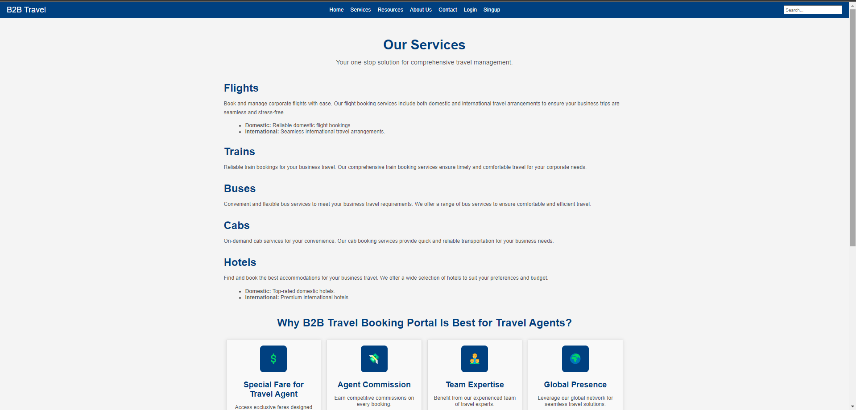

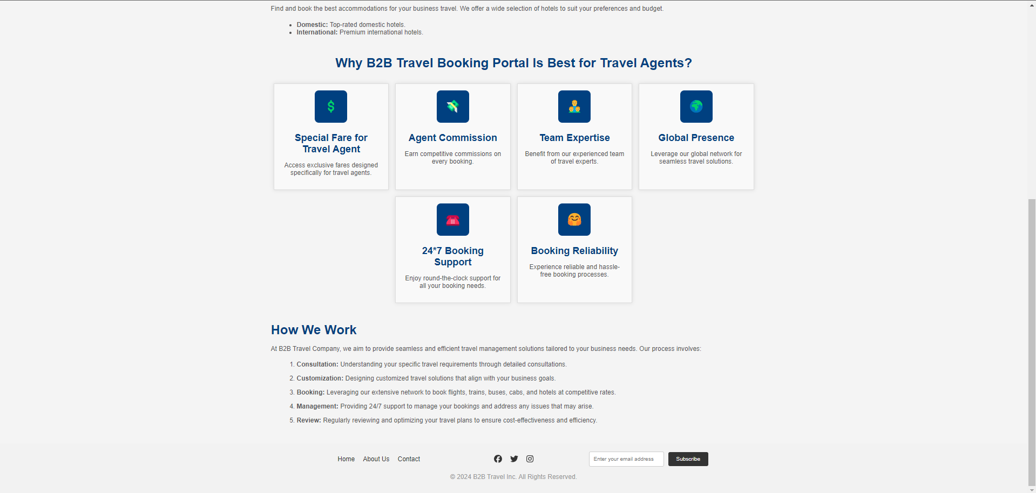

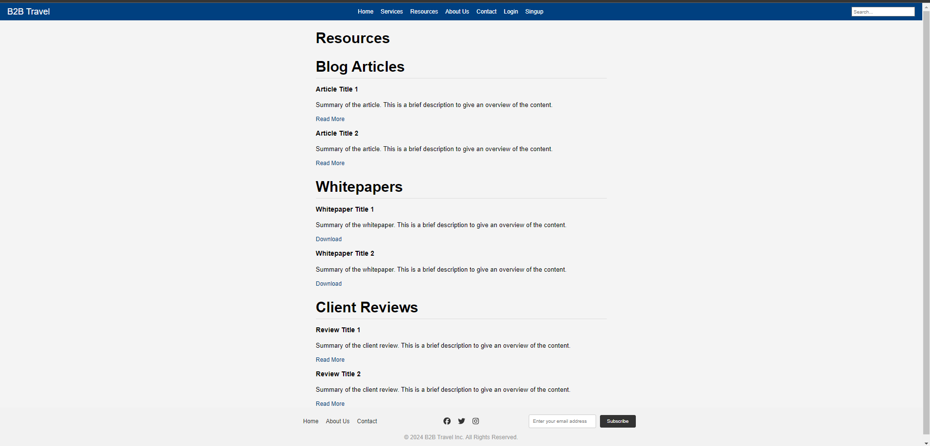

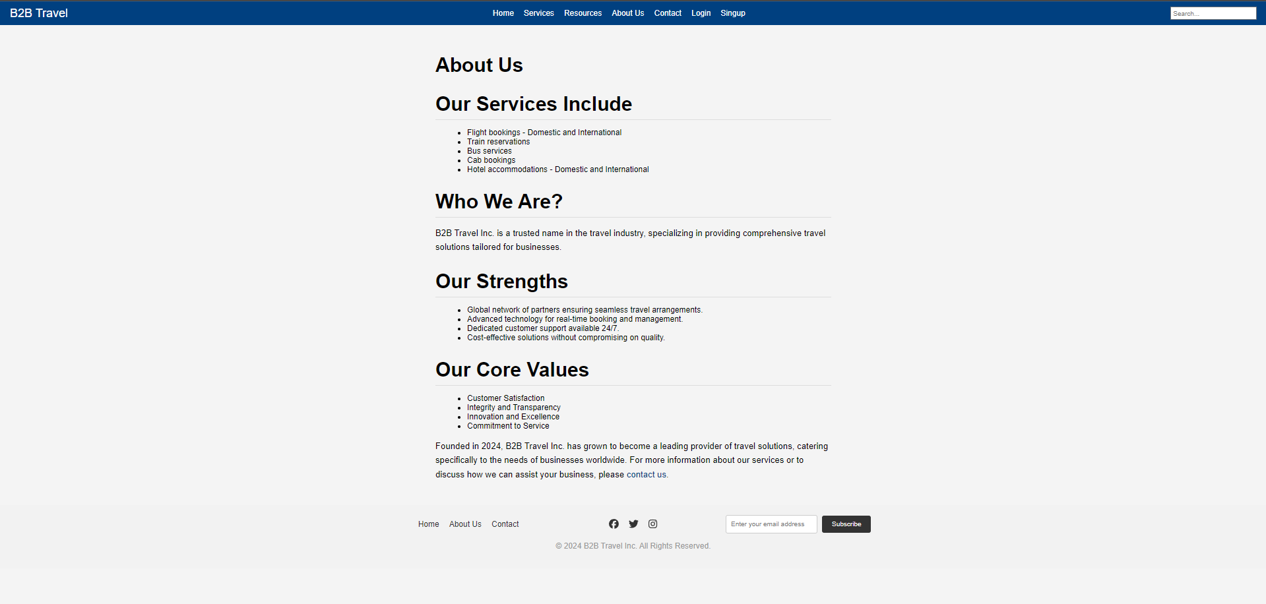

**Week 5:**

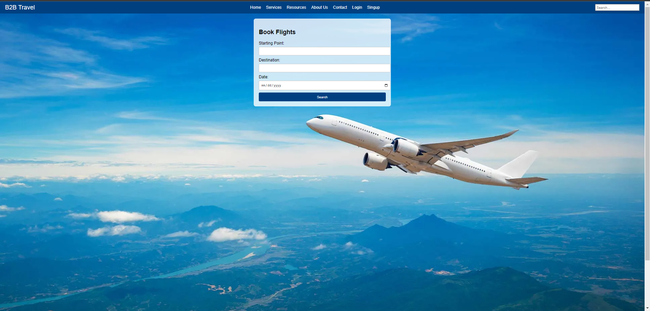

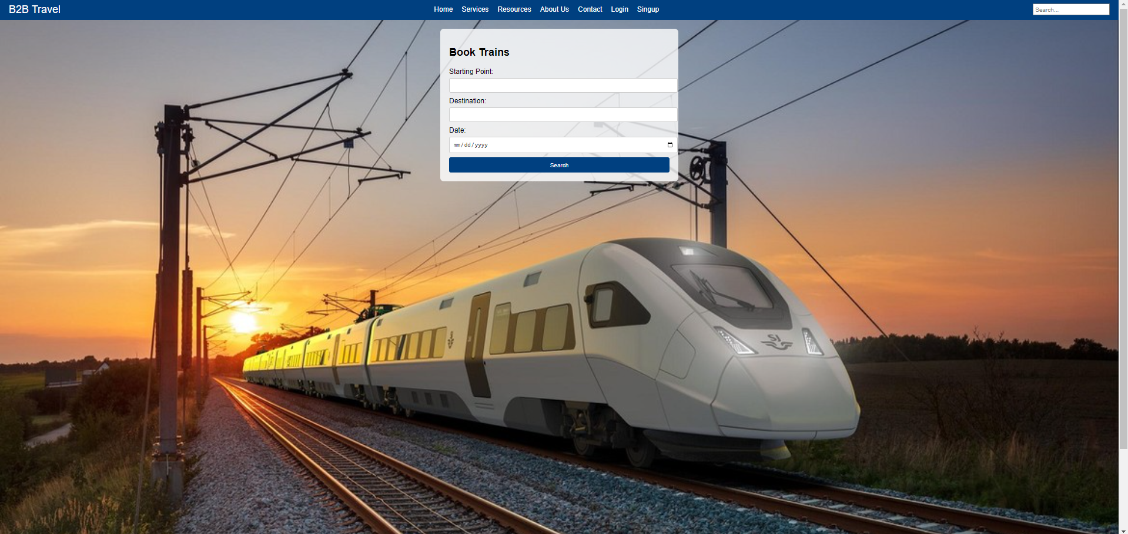

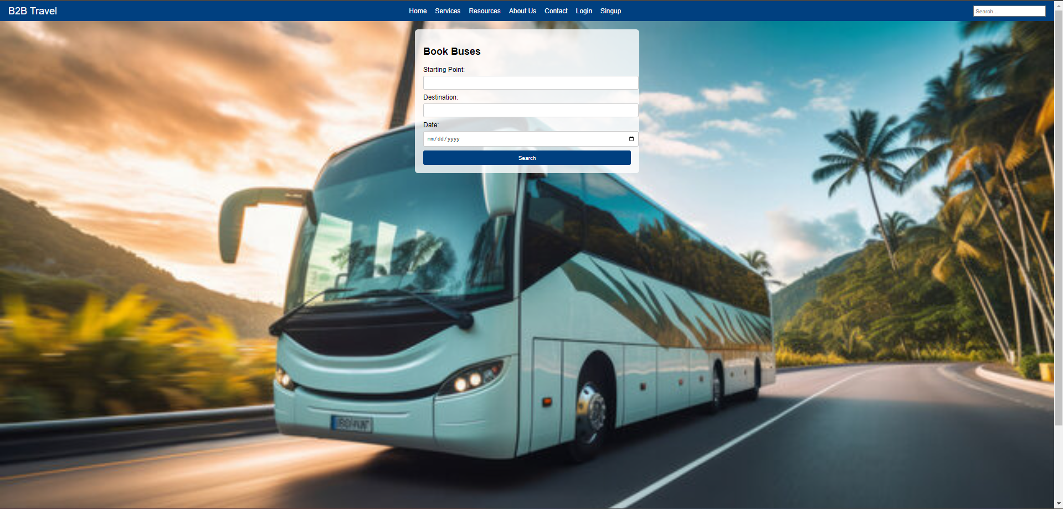

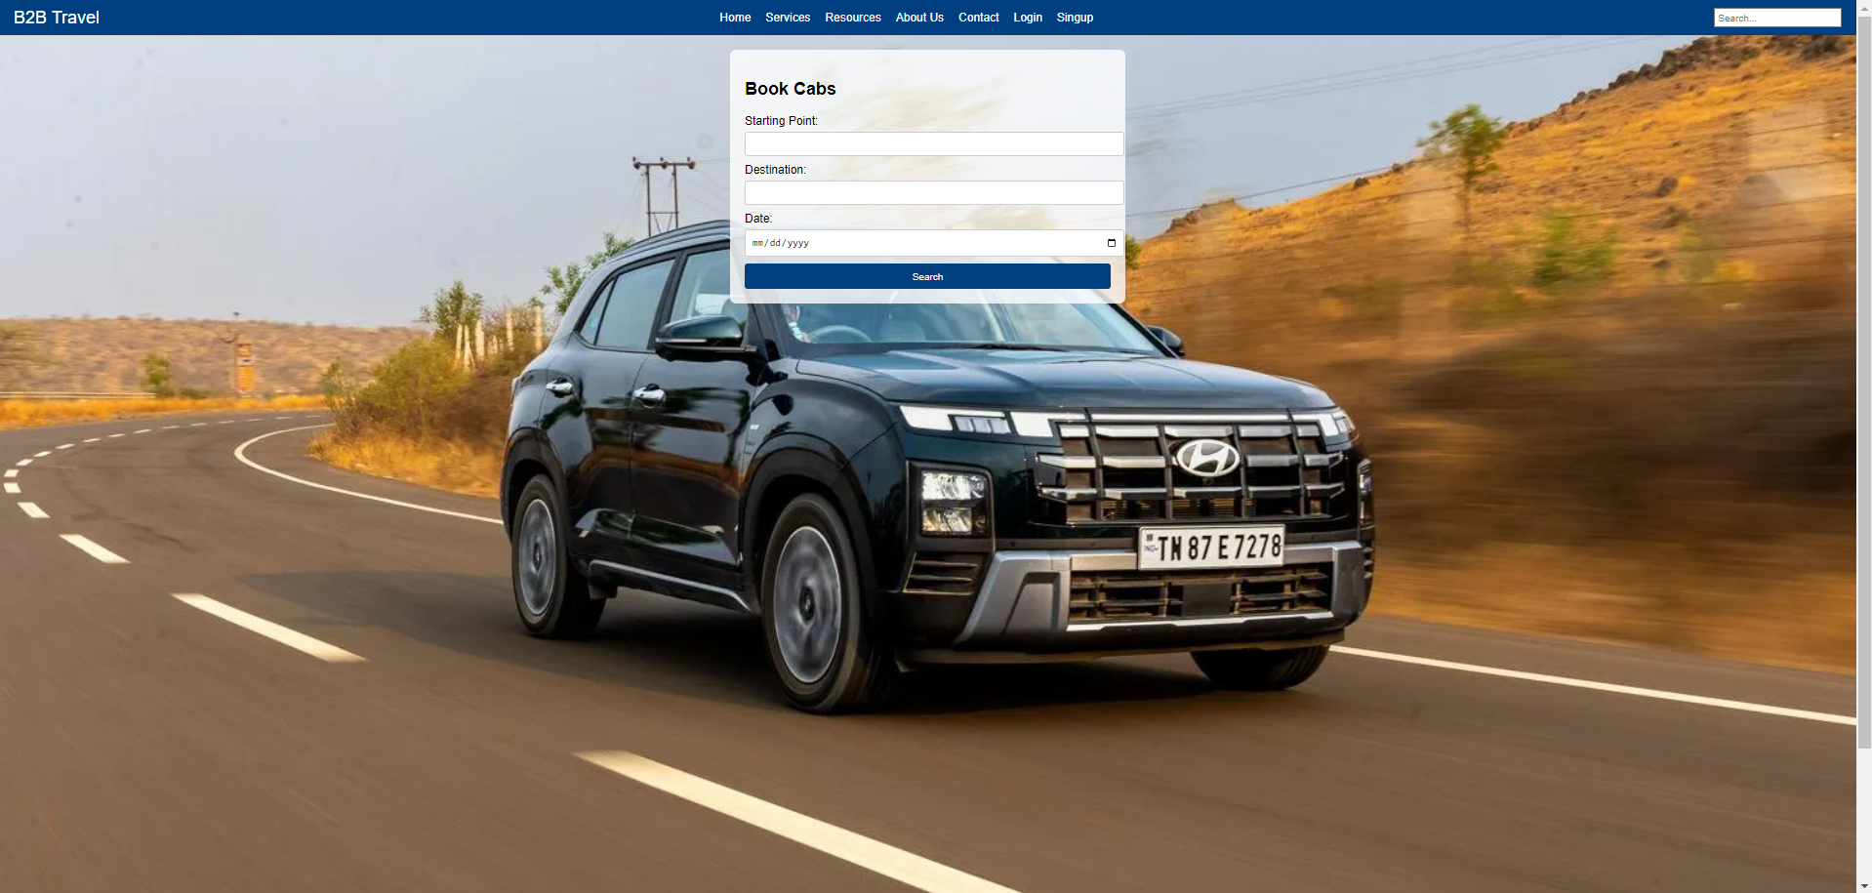

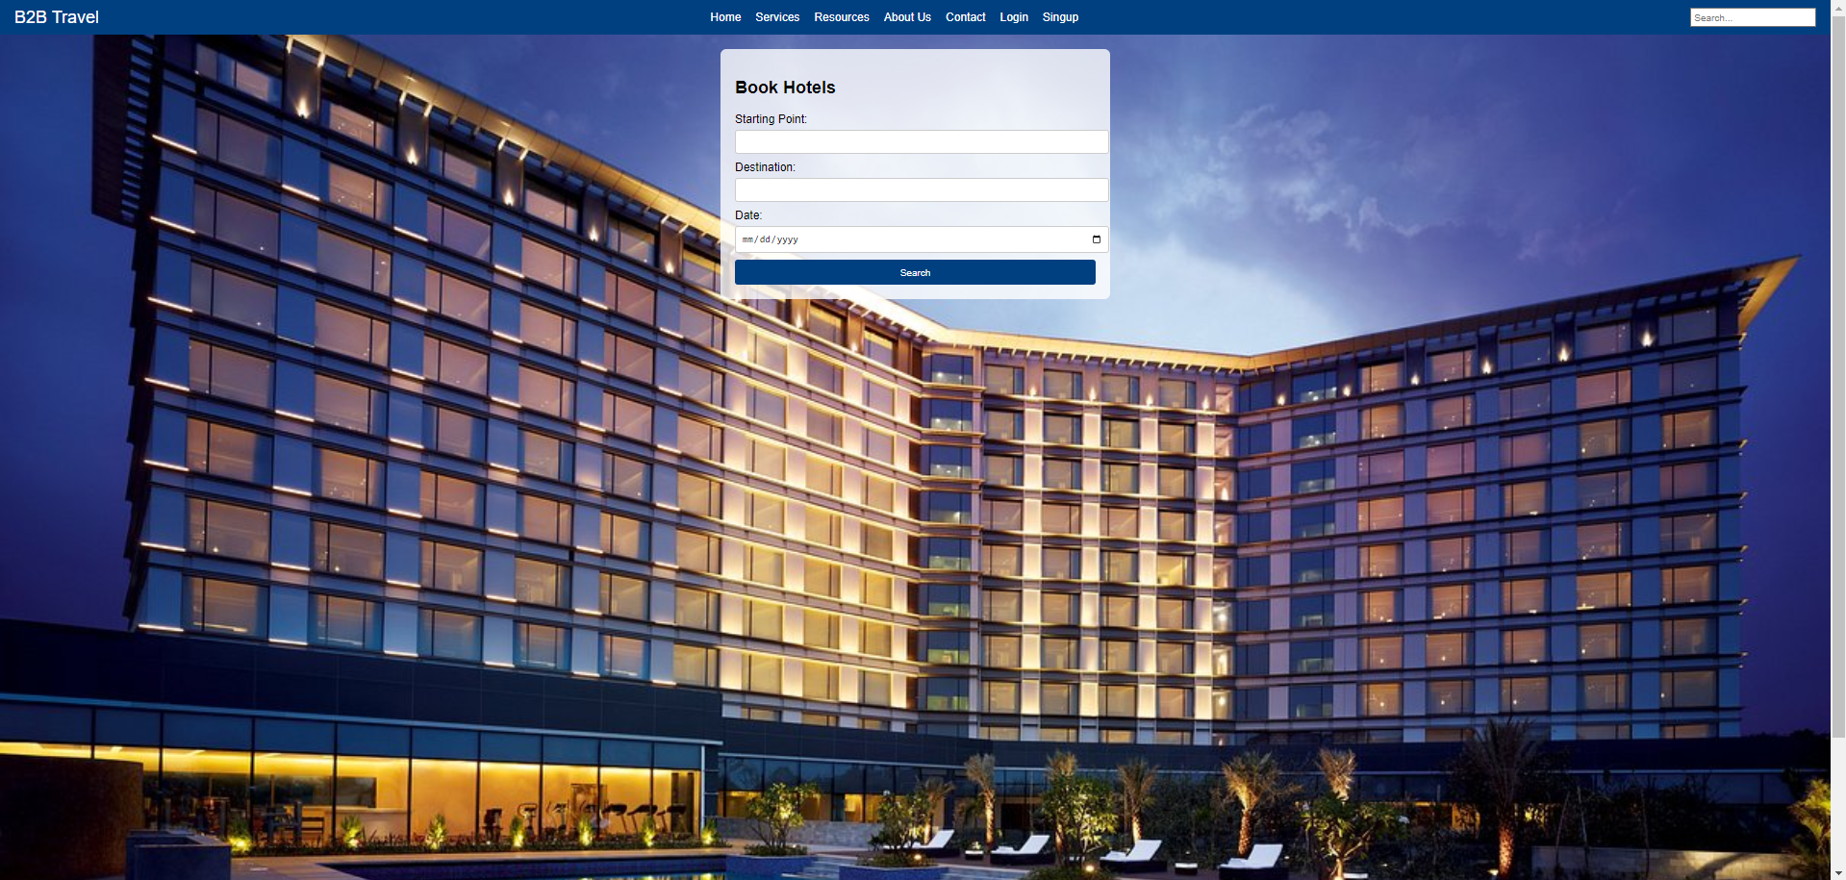

**Week 6:**

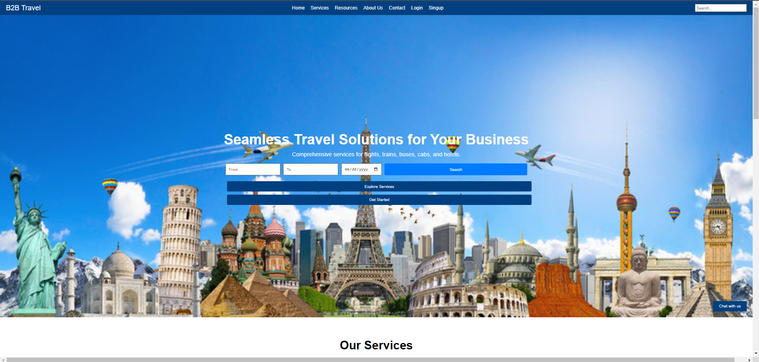

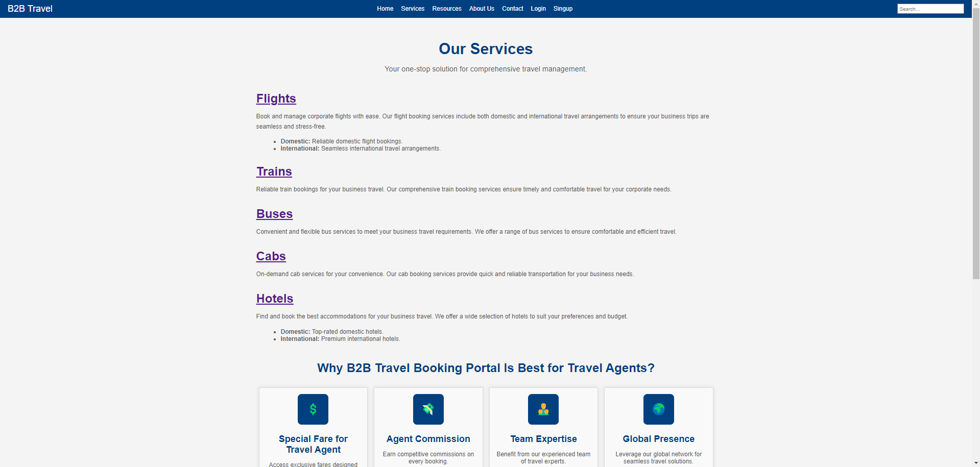

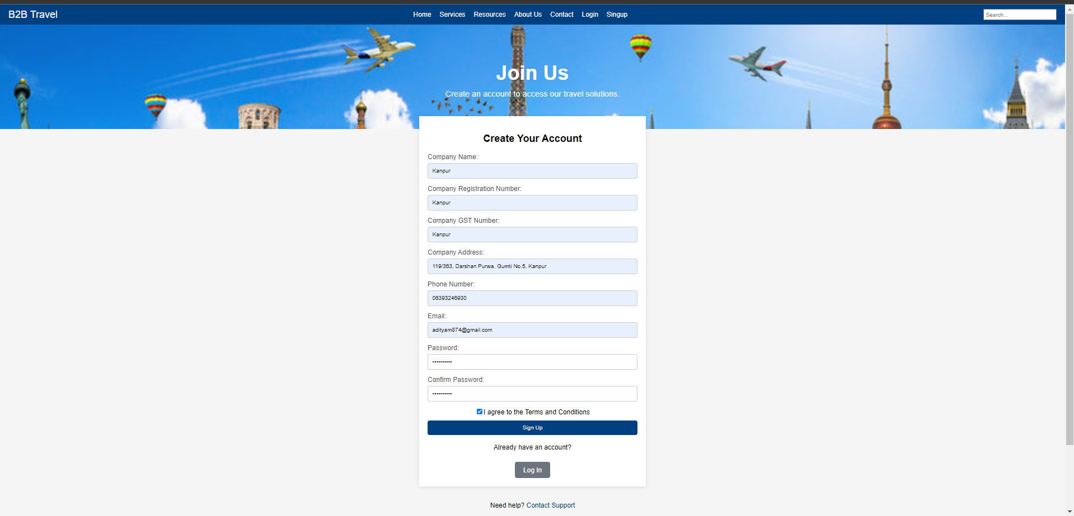

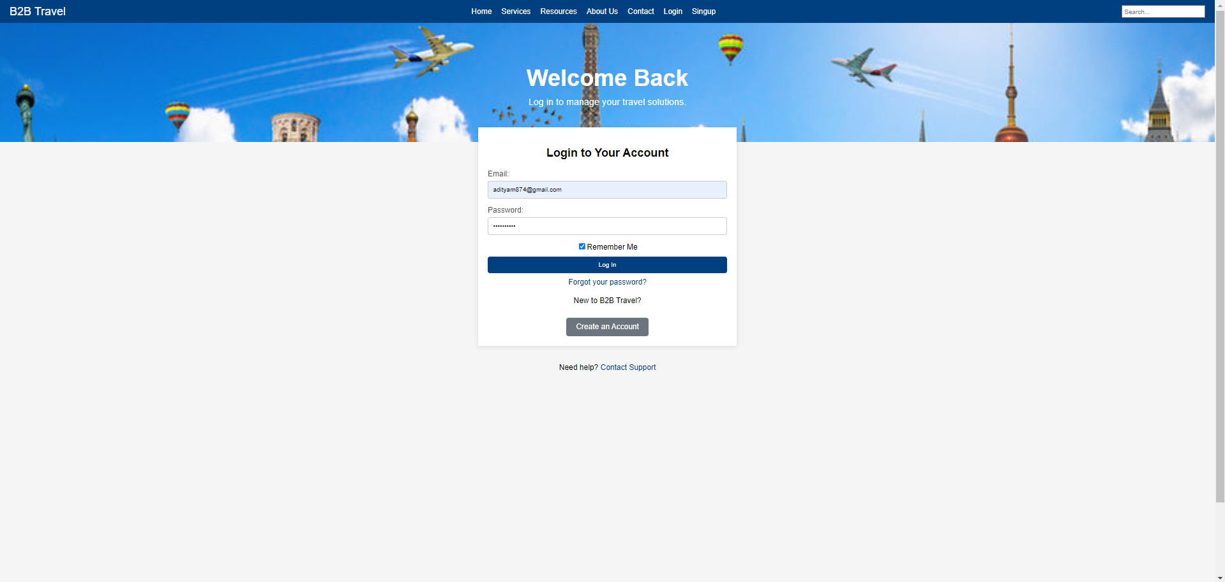

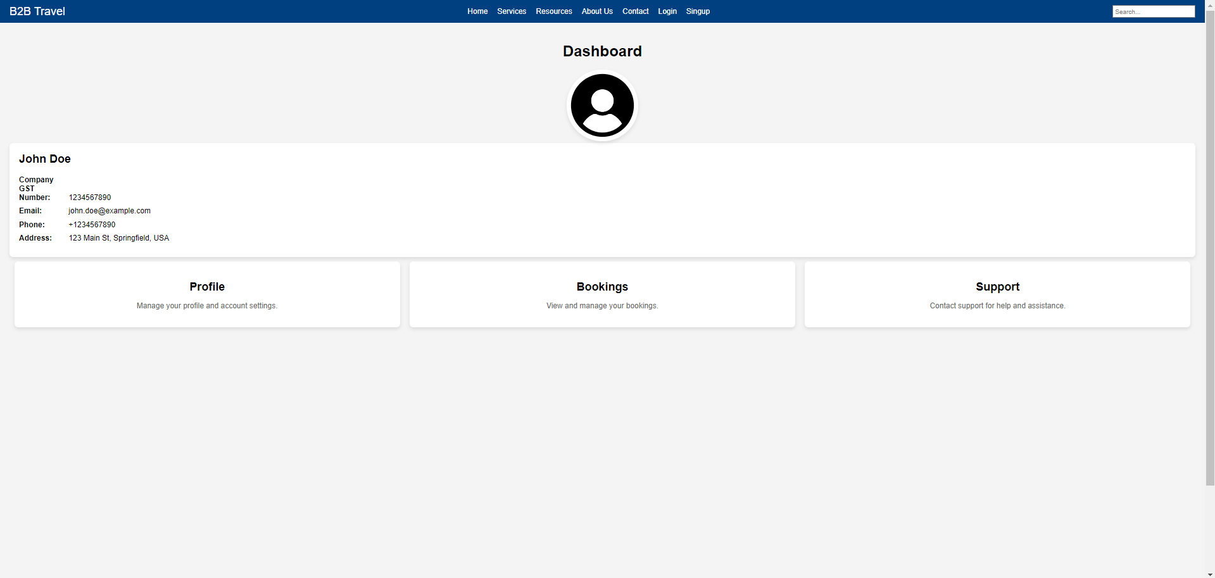

**Week 7:**

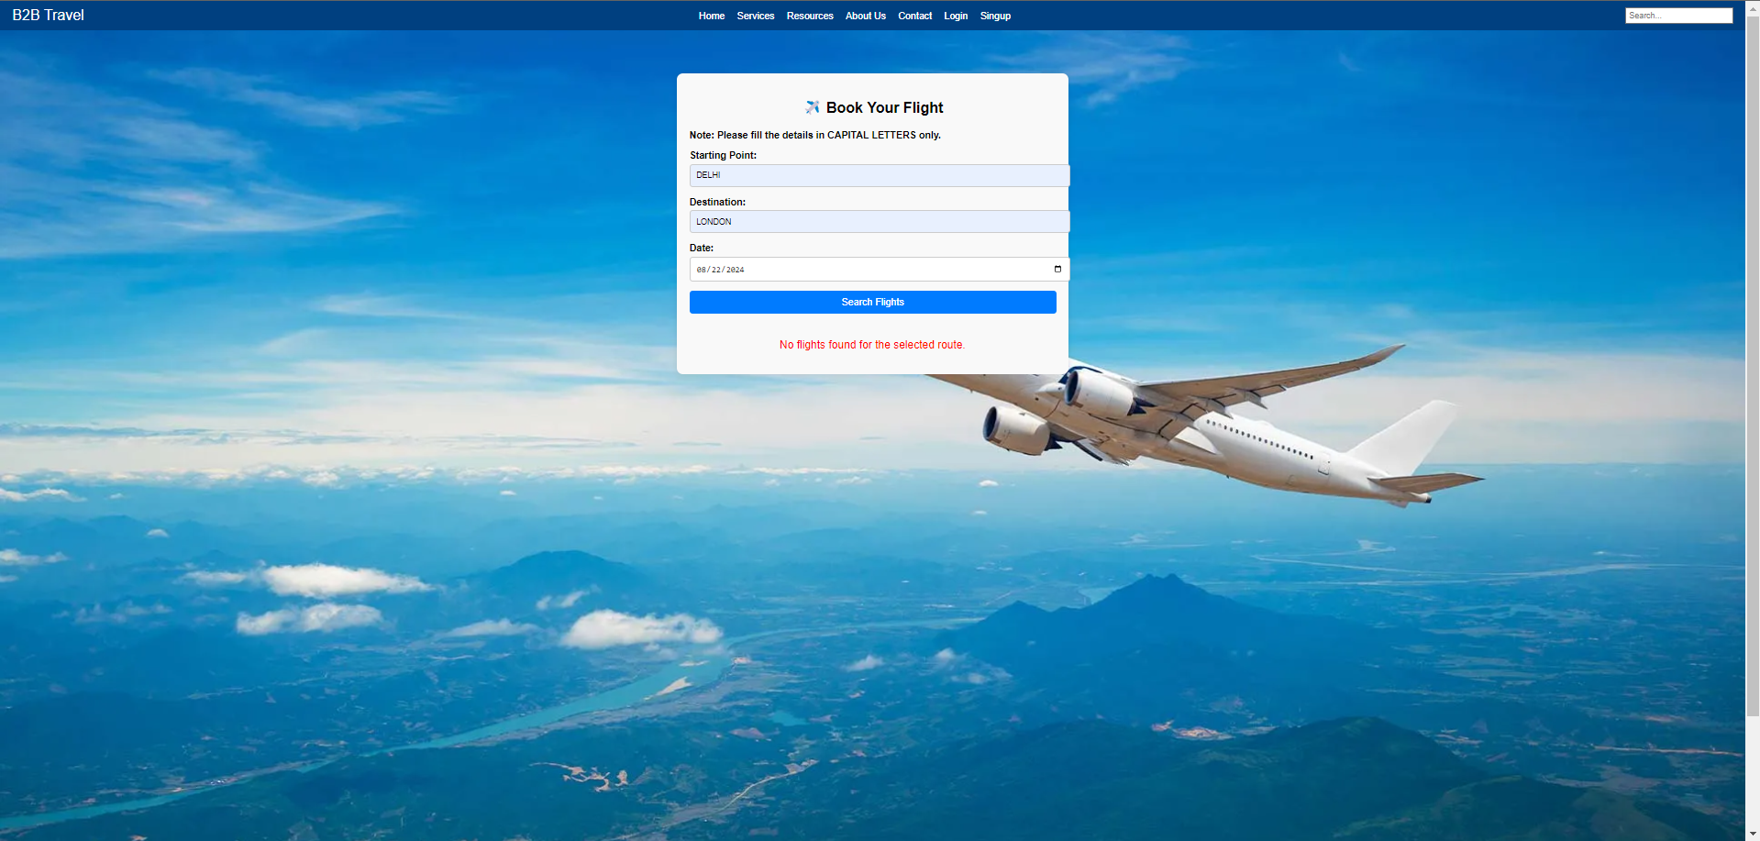

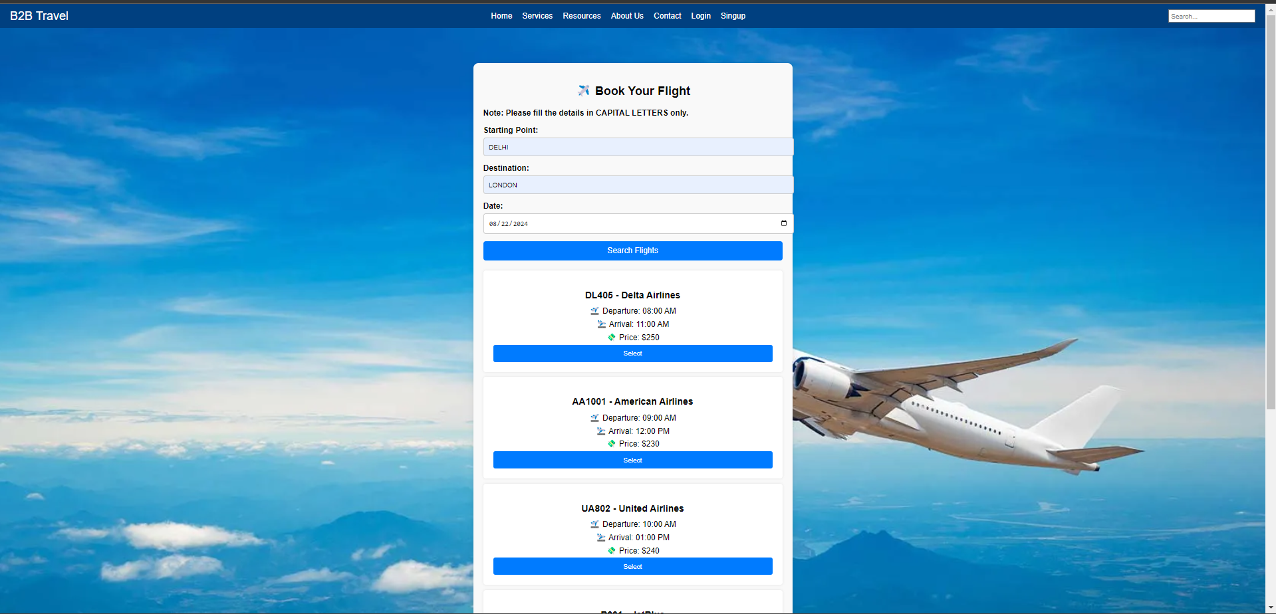

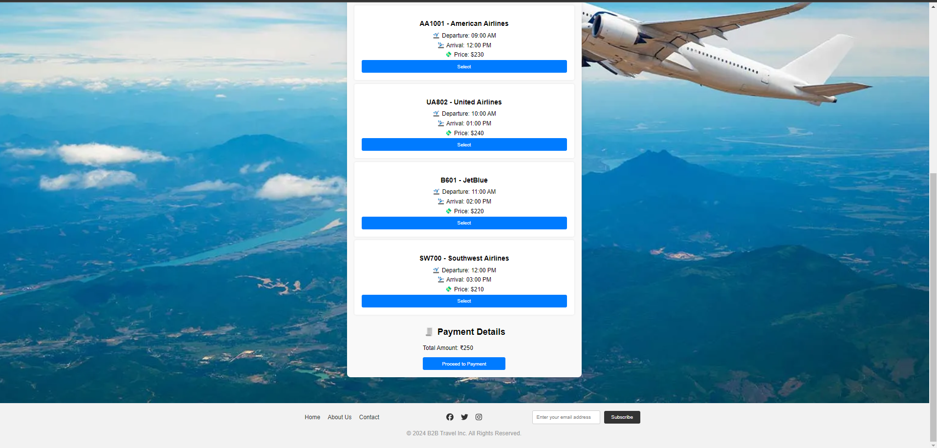

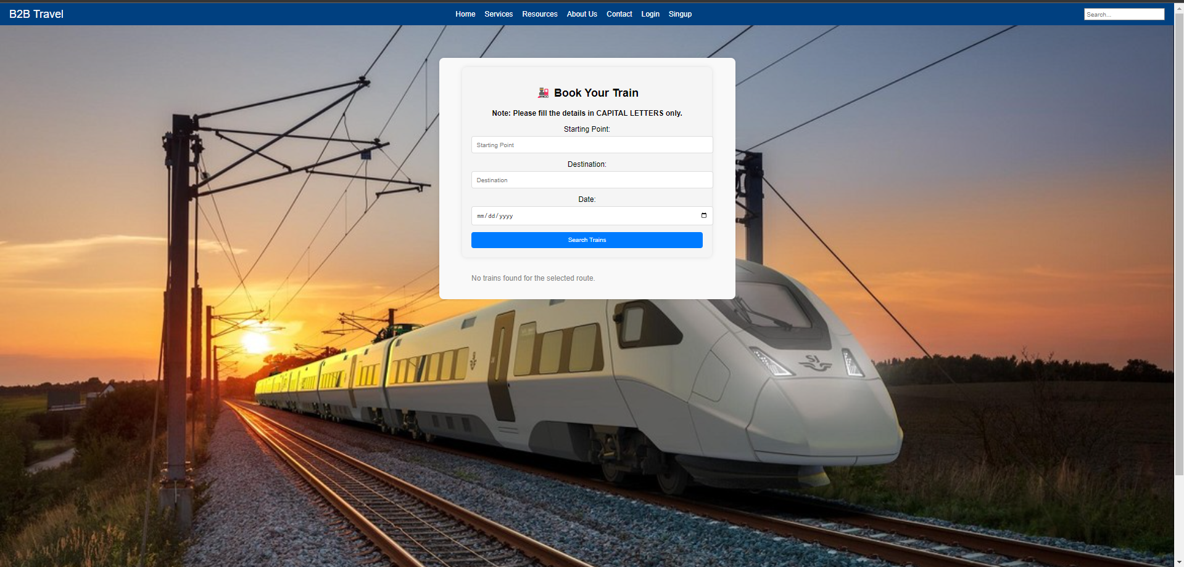

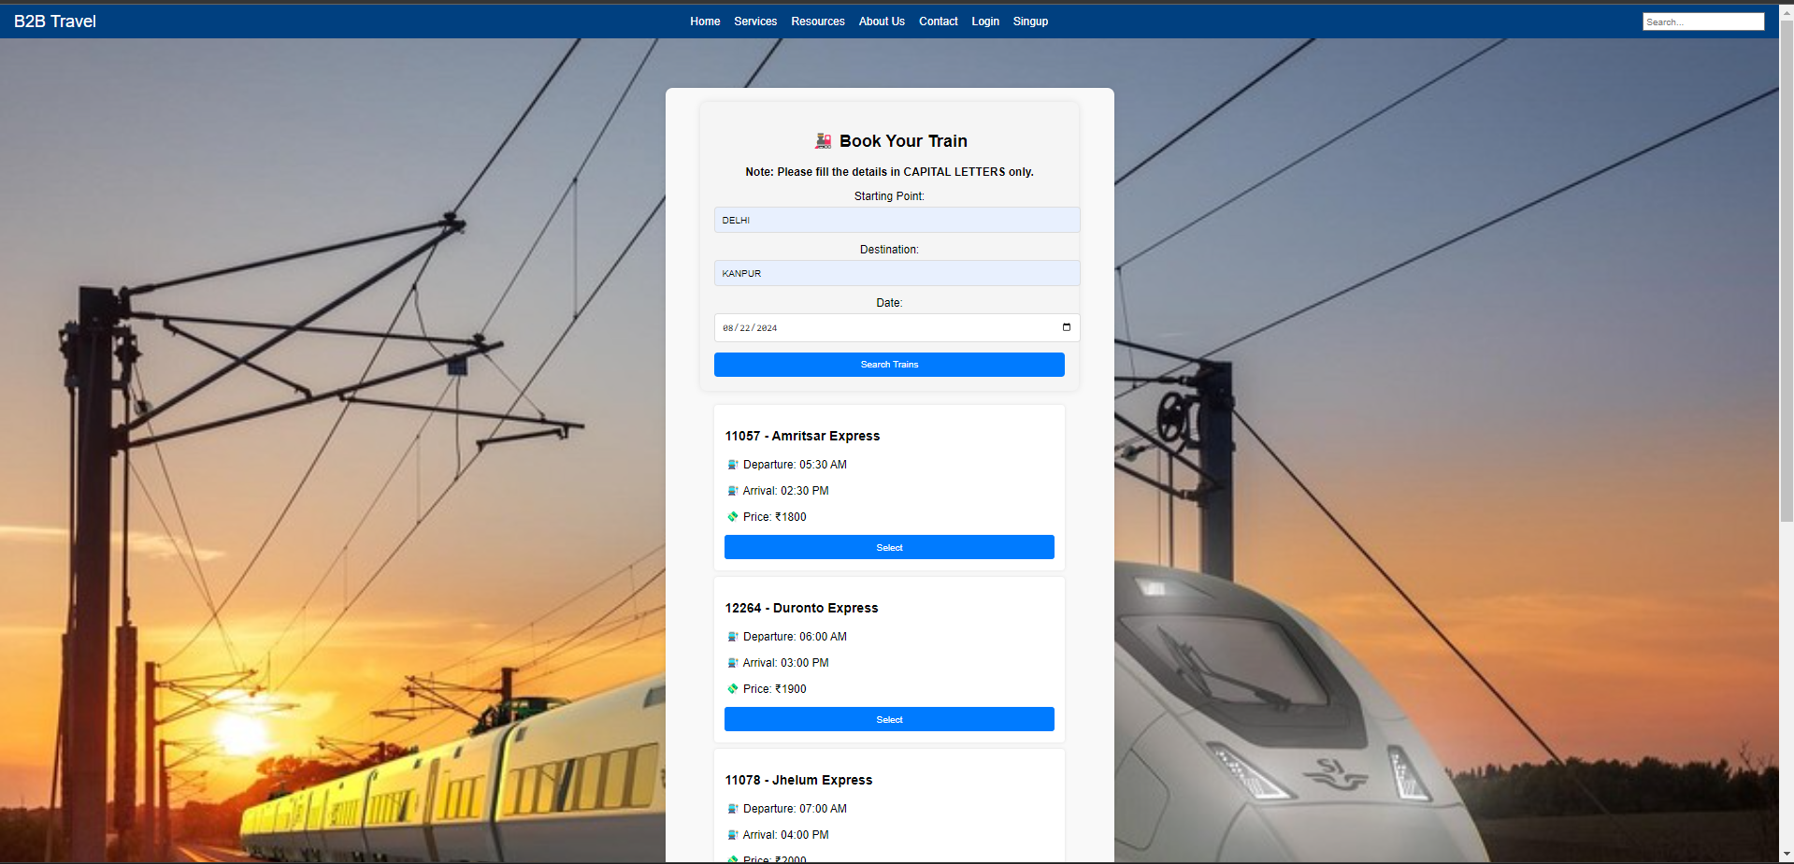

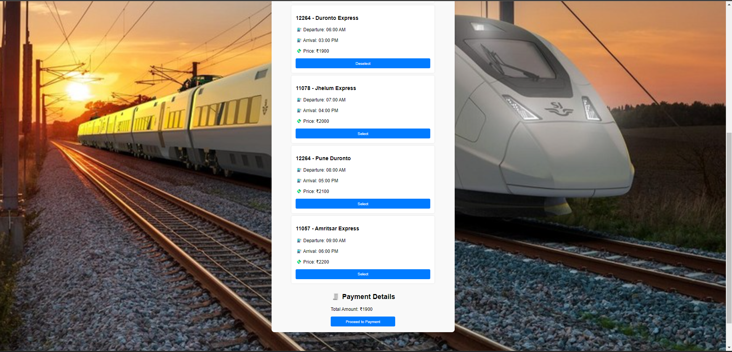

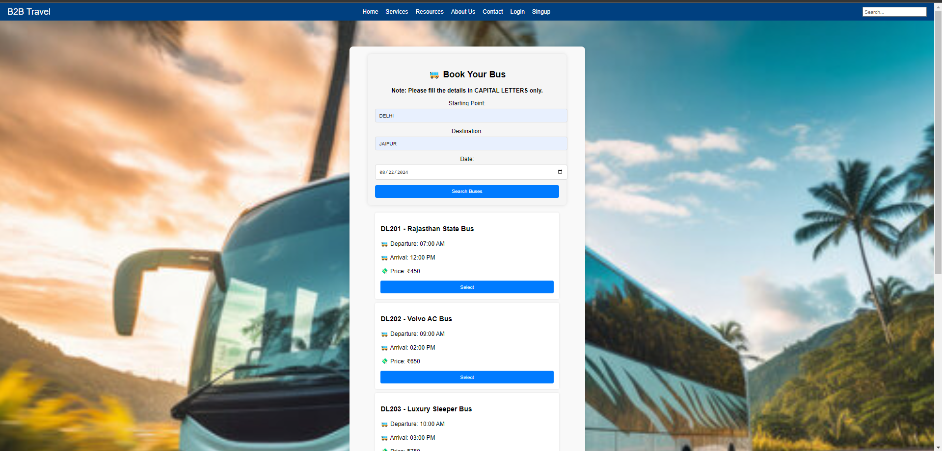

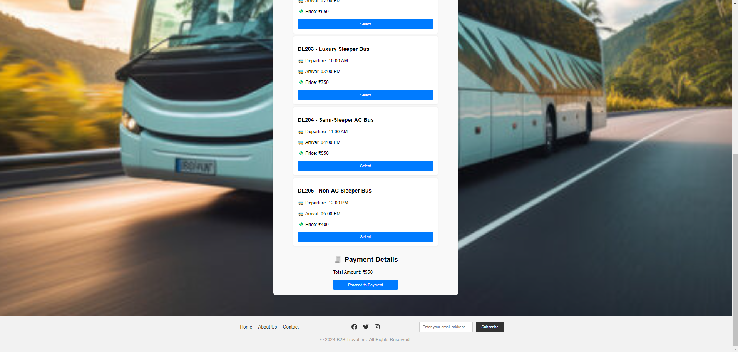

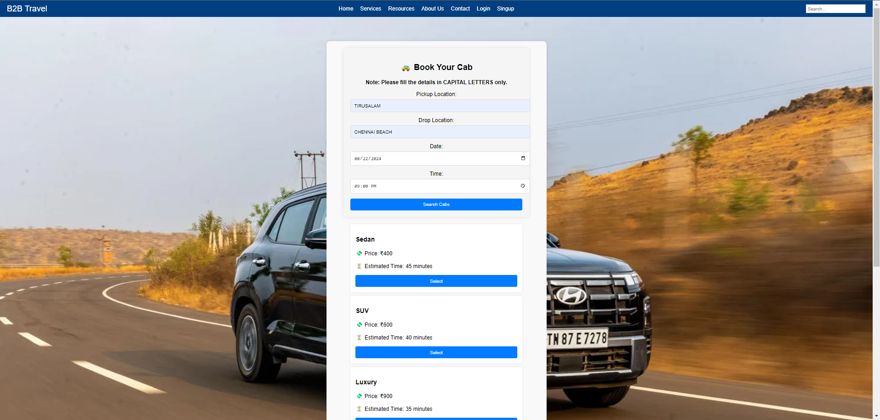

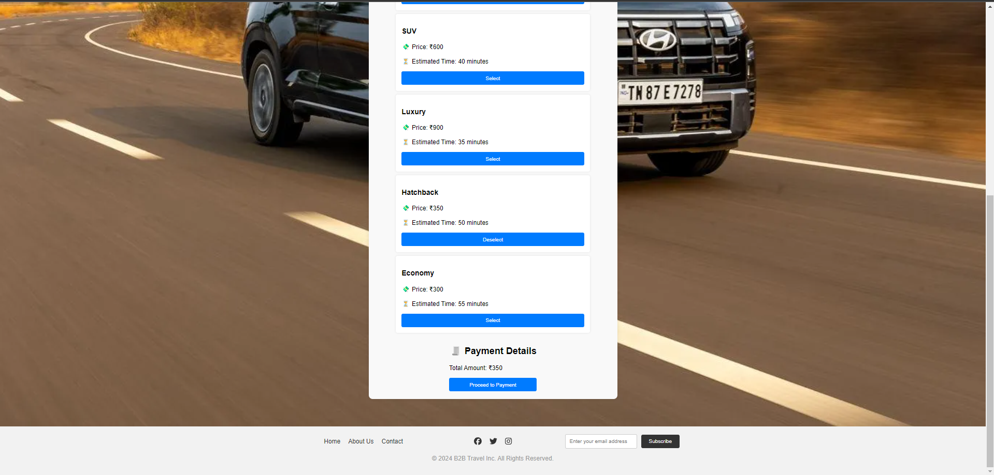

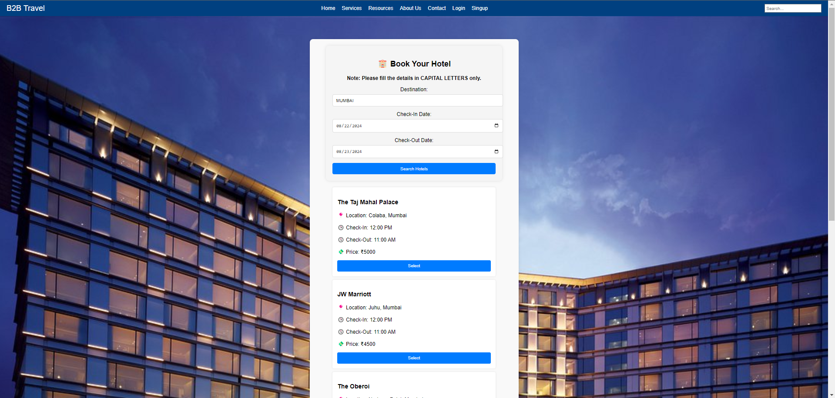

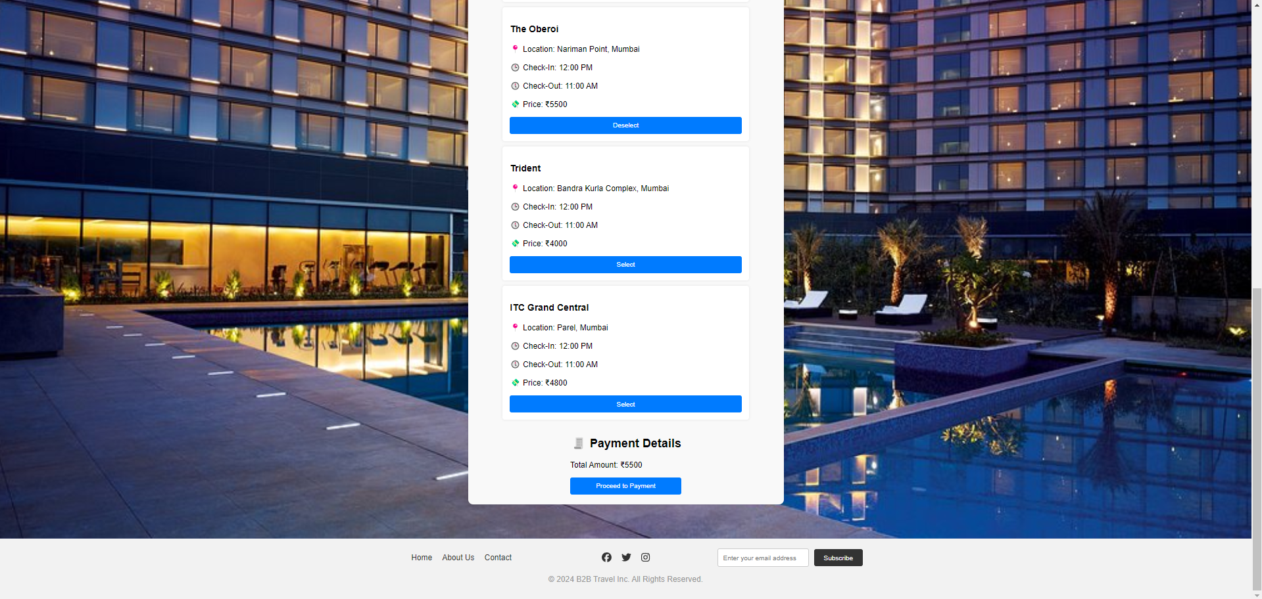

**GitHub:** <https://github.com/mishraji874/B2B-Travel-Compnay>

**Learnings:**

During this project, I gained valuable insights and skills in several areas:

**1. Full-Stack Development:**

**- Frontend Technologies:** Enhanced proficiency in React.js, including component-based design and state management. Improved CSS styling techniques to create responsive and visually appealing layouts.

**- Backend Integration:** Developed an understanding of integrating frontend with backend services and APIs, even using mock data to simulate real-time functionalities.

**2. API Integration:**

**-** Learned how to work with external APIs and handle real-time data. Managed the challenge of using paid APIs by creating mock data and implementing basic examples.

**3. User Experience (UX) Design:**

**-** Gained experience in designing intuitive user interfaces, including navigation, forms, and interactive elements. Focused on user-centered design principles to enhance usability.

**4. Database Management:**

**-** Utilized Firebase for user authentication and data storage, including implementing signup and login functionalities. Gained insight into managing user data and securing it effectively.

**5. Project Management:**

**-** Developed a structured approach to project execution, including weekly planning, task prioritization, and progress tracking. Gained experience in addressing challenges and adapting to limitations, such as API availability.

**6. Deployment Preparation:**

**-** Acquired skills in preparing a website for deployment, including the finalization of features and the integration of payment functionalities.

**Created by:-**

**Aditya Mishra**

[**jobs.adityamsr@gmail.com**](mailto:jobs.adityamsr@gmail.com)

**+916393246930**

**https://autumn-haze-7462.on.fleek.co/**